Practicum Case | 
COMP6583 | COMP6583001
Computer Graphics
Computer Science | E241-COMP6583-HG01-04
Valid on Odd Semester Year 2021/2022 | Revision 00

Learning Outcomes
- Understand how to create 3D objects.

Topics
- Session 04 – Creating 3D Shapes

Sub Topics
- Box
- Cone
- Sphere
- Cylinder
- Wireframe

Creating 3D Shapes
In this session, you are tasked to create a simple 3D model using combination of 3D objects from Three.js. Please create the model of a lighthouse below. Specification for the model will be explained underneath it.
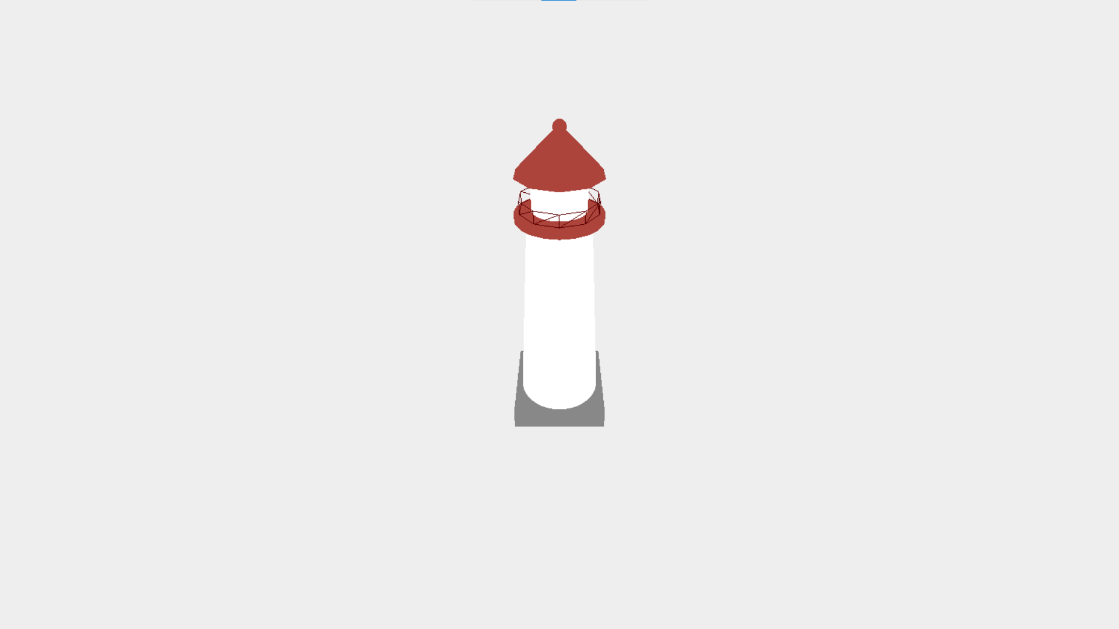
Figure 1. Result
To make this model, we need various 3D objects such as the cylinder, cone, box, and sphere. We will also implement a wireframe to make the fence of the lighthouse.
Before we start with the 3D objects, please set up your three.js project first. Create a three.js project and use a Perspective Camera. Change the camera positions to (0, 34, 30) (x, y, z) and make it look at the (0, 10, 0) position. Also don’t forget to set the renderer clear color to #EEEEEE.
Here are the specifications to make the model.
- Floor (Box)
Box Geometry
Width | 9
Height | 2
Depth | 9

Mesh Basic Material
Color | #888888

Position
(0, 0, 0)

- Body (Cylinder)
Cylinder Geometry
Radius Top | 2.6
Radius Bottom | 4
Height | 20
Radial Segments | 100
Height Segments | 1
Open Ended | false

Mesh Basic Material
Color | #FFFFFF

Position
(0, 10, 0)

- Neck (Cylinder)
Cylinder Geometry
Radius Top | 3.6
Radius Bottom | 3.6
Height | 0.5
Radial Segments | 20
Height Segments | 1
Open Ended | false

Mesh Basic Material
Color | #AC443C

Position
(0, 20, 0)

- Fence (Cylinder Wireframe)
Cylinder Geometry
Radius Top | 3.2
Radius Bottom | 3.2
Height | 1
Radial Segments | 10
Height Segments | 1
Open Ended | true

Mesh Basic Material
Color | #5C0000
Wireframe | True

Position
(0, 21, 0)

- Head (Cylinder)
Cylinder Geometry
Radius Top | 2.2
Radius Bottom | 2.2
Height | 3
Radial Segments | 30
Height Segments | 1
Open Ended | false

Mesh Basic Material
Color | #FFFFFF

Position
(0, 22, 0)

- Roof (Cone)
Cone Geometry
Radius | 3.5
Height | 3.5
Radial Segments | 100
Height Segments | 1
Open Ended | false

Mesh Basic Material
Color | #AC443C

Position
(0, 25, 0)

- Top Part (Sphere)
Sphere Geometry
Radius | 0.5

Mesh Basic Material
Color | #AC443C

Position
(0, 26.5, 0)

